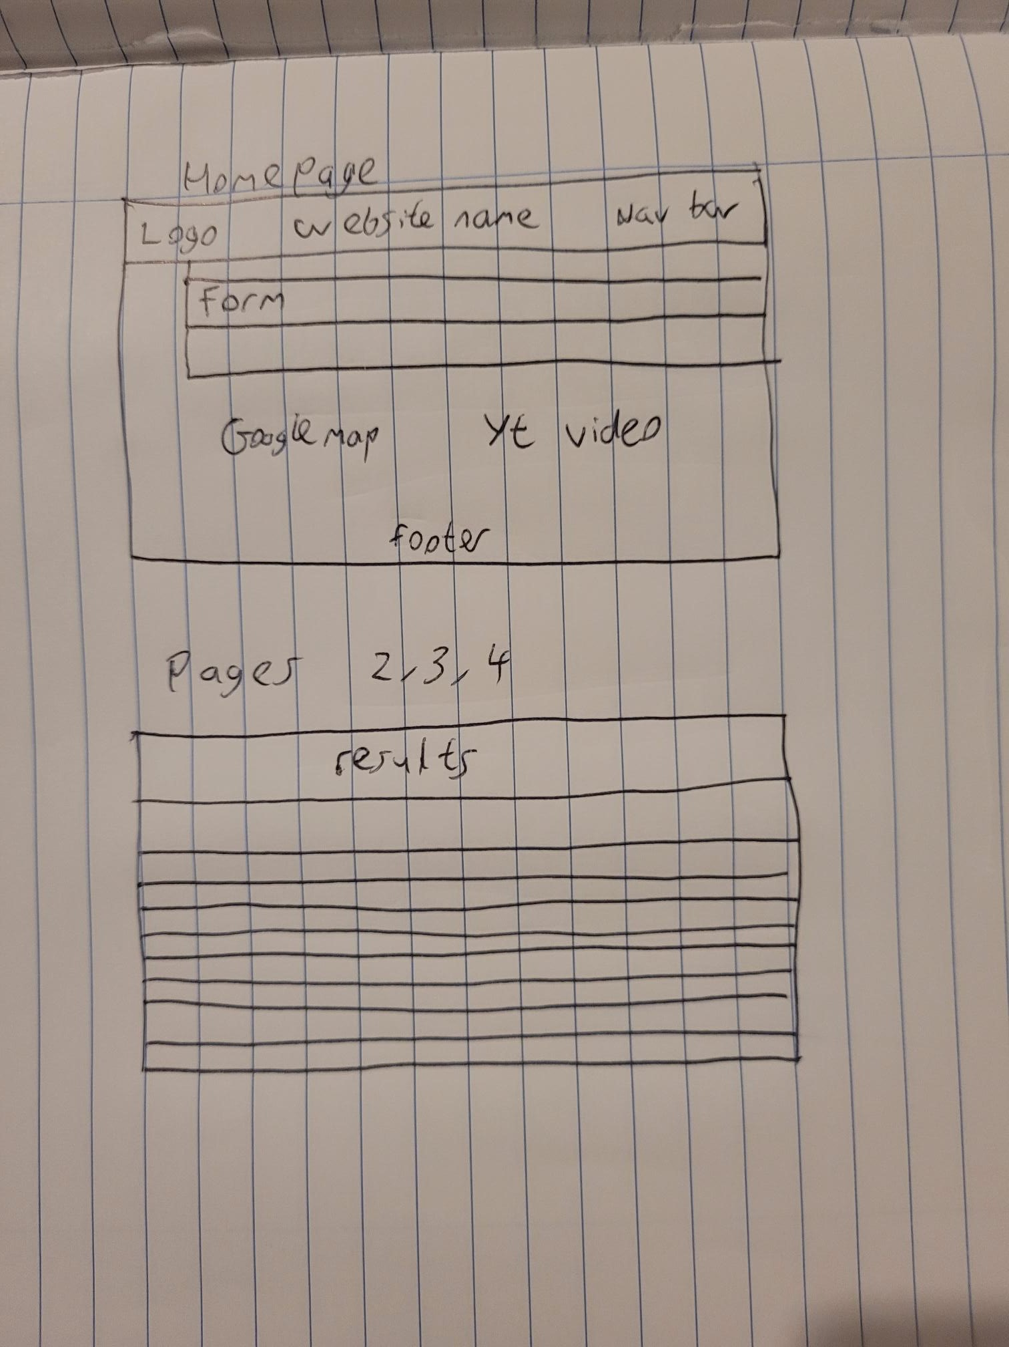

My website will be laid out over four pages. There will be a home page With a navbar to the other 3 pages as well as website name and logo. It will also have a form to ask a question as well as a youtube video and somewhere on google maps. The other 3 pages will all have the results of football games form 3 different leagues.